



Christmas songs

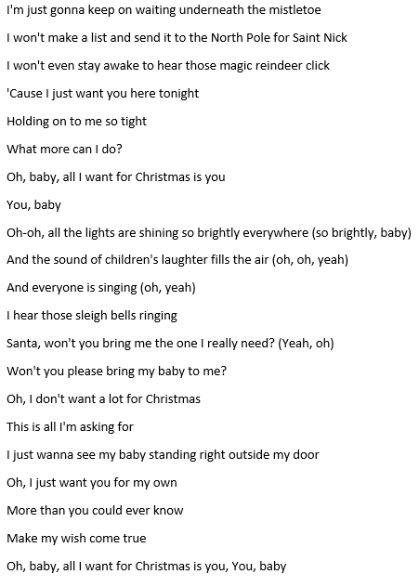
All I Want for Christmas

I don't want a lot for Christmas
There is just one thing I need
I don't care about the presents underneath the Christmas tree
I just want you for my own
More than you could ever know
Make my wish come true
All I want for Christmas is you, Yeah
I don't want a lot for Christmas
There is just one thing I need (and I)
Don't care about the presents underneath the Christmas tree
I don't need to hang my stocking there upon the fireplace
Santa Claus won't make me happy with a toy on Christmas Day
I just want you for my own
More than you could ever know
Make my wish come true
All I want for Christmas is you
You, baby
Oh, I won't ask for much this Christmas
I won't even wish for snow (and I)
I Saw Mommy Kissing Santa Claus
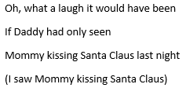
I saw Mommy kissing Santa Claus
Underneath the mistletoe last night.
She didn’t see me creep
down the stairs to have a peep.
She thought that I was tucked
up in my bedroom fast asleep.

Then, I saw Mommy tickle Santa Claus
Underneath his beard so snowy white.
Oh, what a laugh it would have been
If Daddy had only seen
Mommy kissing Santa Claus last night

Then I saw Mommy tickle Santa Claus
Underneath his beard so snowy white
Oh, what a laugh it would have been
If Daddy had only seen
Mommy kissing Santa Claus last night

Feliz Navidad

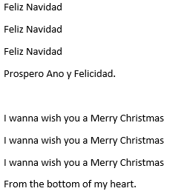
Feliz Navidad
Feliz Navidad
Feliz Navidad
Prospero Ano y Felicidad.

Feliz Navidad
Feliz Navidad
Feliz Navidad
Prospero Ano y Felicidad.

I wanna wish you a Merry Christmas
I wanna wish you a Merry Christmas
I wanna wish you a Merry Christmas
From the bottom of my heart.

Feliz Navidad
Feliz Navidad
Feliz Navidad
Prospero Ano y Felicidad.
Jingle Bell Rock

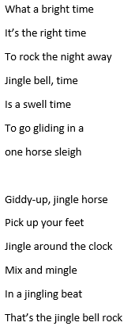
Jingle bell, jingle bell
Jingle bell rock
Jingle bell swing
and jingle bells ring
Snowing and blowing up
bushels of fun
Now the jingle hop has begun

Jingle bell, jingle bell
Jingle bell rock
Jingle bells chime in
Jingle bell time
Dancing and prancing
In jingle bell square
In the frosty air

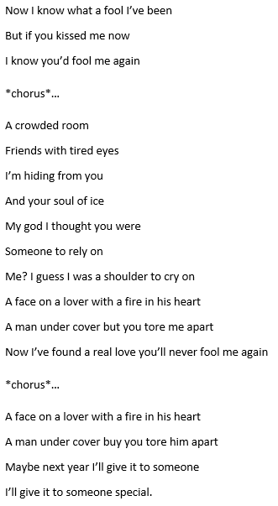
Last Christmas

Last Christmas
I gave you my heart
But the very next day you gave it away
This year
To save me from tears
I’ll give it to someone special

Once bitten and twice shy
I keep my distance
But you still catch my eye
Tell me baby
Do you recognize me?
Well
It’s been a year
It doesn’t surprise me
I wrapped it up and sent it
With a note saying “I love you”
I meant it

Let it Snow

Oh, the weather outside is frightful
But the fire is so delightful
And since we’ve no place to go
Let It Snow! Let It Snow! Let It Snow!

It doesn’t show signs of stopping
And I’ve bought some corn for popping
The lights are turned way down low
Let It Snow! Let It Snow! Let It Snow!

When we finally kiss goodnight
How I’ll hate going out in the storm!
But if you’ll really hold me tight
All the way home I’ll be warm

The fire is slowly dying
And, my dear, we’re still goodbying
But as long as you love me so
Let It Snow! Let It Snow! Let It Snow!
Rocking around the Christmas tree

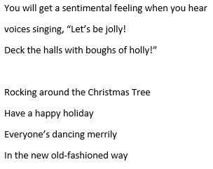
Rocking around the Christmas Tree
at the Christmas party hop
Mistletoe hung where you can see
Every couple tries to stop

You will get a sentimental feeling when you hear
voices singing, “Let’s be jolly!
Deck the halls with boughs of holly!”

Rocking around the Christmas Tree
Have a happy holiday
Everyone’s dancing merrily
In the new old-fashioned way

Rocking around the Christmas Tree
Let the Christmas Spirit ring
Later we’ll have some pumpkin pie
and we’ll do some caroling

Santa Claus is coming to town

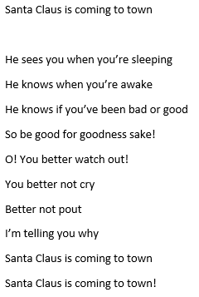
You better watch out
You better not cry
Better not pout
I’m telling you why
Santa Claus is coming to town

He’s making a list
And checking it twice;
Gonna find out Who’s naughty and nice
Santa Claus is coming to town

He sees you when you’re sleeping
He knows when you’re awake
He knows if you’ve been bad or good
So be good for goodness sake!
O! You better watch out!
You better not cry
Better not pout
I’m telling you why
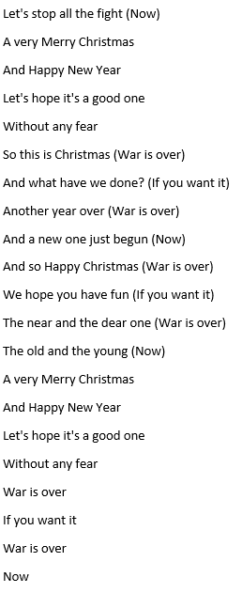
Happy Xmas

So this is Christmas
And what have you done?
Another year over
And a new one just begun
And so this is Christmas
I hope you have fun
The near and the dear one
The old and the young
A very Merry Christmas
And Happy New Year
Let's hope it's a good one
Without any fear
And so this is Christmas (War is over)
For weak and for strong (If you want it)
For rich and the poor ones (War is over)
The road is so long (Now)
And so Happy Christmas (War is over)
For black and for white (If you want it)
For yellow and red ones (War is over)
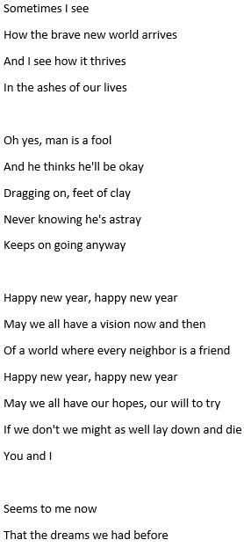
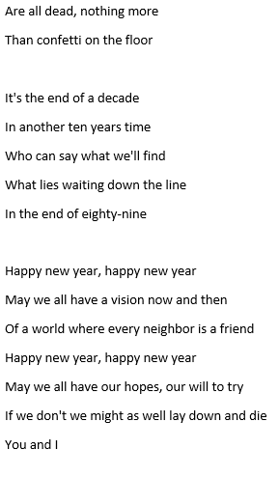
Happy New Year

No more champagne
And the fireworks are through
Here we are, me and you
Feeling lost and feeling blue

It's the end of the party
And the morning seems so gray
So unlike yesterday
Nows the time for us to say

Happy new year, happy new year
May we all have a vision now and then
Of a world where every neighbor is a friend
Happy new year, happy new year
May we all have our hopes, our will to try
If we don't we might as well lay down and die
You and I

Rudolph, the Red-Nosed Reindeer
You know Dasher and Dancer and Prancer and Vixen
Comet and Cupid and Donner and Blitzen
But do you recall
The most famous reindeer of all?
Rudolph the Red-Nosed Reindeer
Had a very shiny nose
And if you ever saw it
You would even say it glows
All of the other reindeer
Used to laugh and call him names
They never let poor Rudolph
Join in any reindeer games
Then one foggy Christmas Eve
Santa came to say
"Rudolph, with your nose so bright
Won't you guide my sleigh tonight?"
Then how the reindeer loved him
As they shouted out with glee
"Rudolph the Red-Nosed Reindeer
You'll go down in history"
Rudolph the Red-Nosed Reindeer
Had a very shiny nose
And if you ever saw it
You would even say it glows
They never let poor Rudolph
Join in any reindeer games
Then one foggy Christmas Eve
Santa came to say
"Rudolph, with your nose so bright
Won't you guide my sleigh tonight?"
Then how the reindeer loved him
As they shouted out with glee
"Rudolph the Red-Nosed Reindeer
You'll go down in history"

